

Client User Password Reset Guide

# Deloitte Tools

## The following instructions will help you reset a **temporary, forgotten,** or **expired password** for your Deloitte account associated with the following tools:

* Application Management - Process Manager (AM-PM)
* Application Lifecycle Management (ALM)
* Confluence
* Deloitte OnLine (DOL)
* IndustryPrint 5 (IP5)
* Jira
* Octane
* Performance Center (PC)
* Project Management Center (PMC)
* SonarQube

# Instructions - Reset Temporary Password

## Perform the following steps to reset your temporary Deloitte password:

1. Upon creation of your Deloitte user account, you will automatically receive **two emails** from DeloitteSystemAccess@deloitte.com which contain information you will need in order to complete step #4:

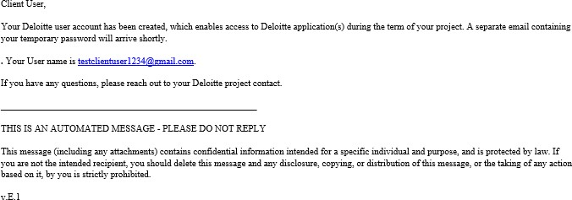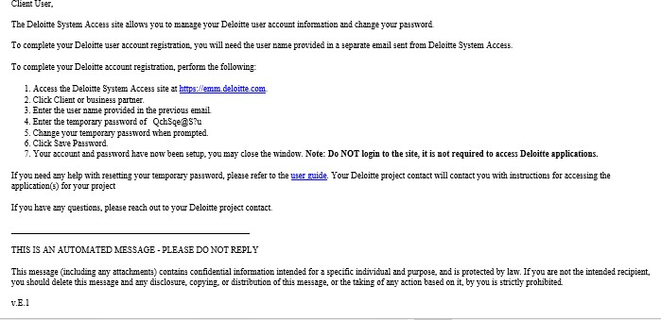

*Note: If you don’t see these mails in your inbox, we recommend you check the Spam/Junk folder. If you still cannot find these emails, please refer to the “forgotten or expired password reset” instructions further in this guide.*

1. Access the URL [https://emm.deloitte.com](https://emm.deloitte.com/).
2. Click **Sign In** button under **Client or business partner** as our consulting tools do **NOT** support client users with other account options.

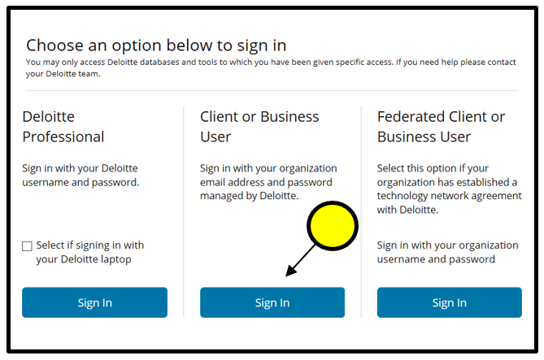

1. Enter email address as received in the first email notification and the temporary password as provided in the second email. Then click on **Sign In.**

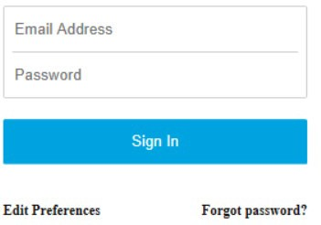

1. On the **Create a New Password** page, provide the temporary password received via email and enter a new password twice to confirm. Click on **Save Password.**

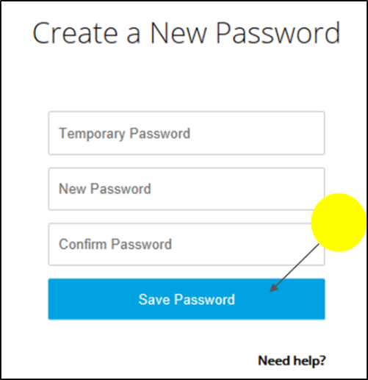

1. A message pops up after password has changed. You can either click on

**Continue** or wait for the login screen to appear.

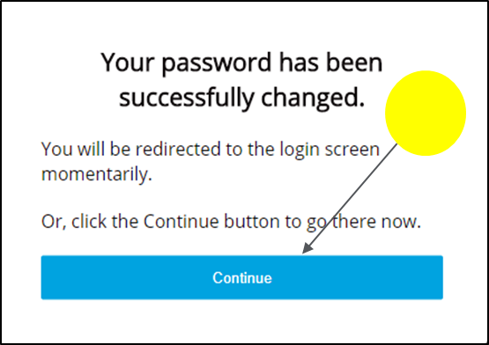

1. Your account and password have now been setup. Do **NOT** click on **Sign In** with your username and new password as DSA will prompt you to enroll into DPASS MFA (not required) that is different from the Consulting MFA and will not allow a user to access a consulting tool.

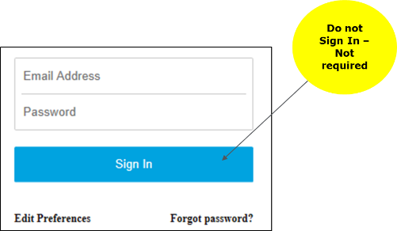

# Instructions – Reset Forgotten or Expired Password

Perform the following steps to reset a forgotten or expired password (which occurs every 84 days). These steps are also applicable for users who did not receive the two registration emails from [DeloitteSystemAccess@deloitte.com](mailto:DeloitteSystemAccess@deloitte.com) that contains the username and temporary password.

1. Access the URL [https://emm.deloitte.com](https://emm.deloitte.com/).
2. Click **Sign In** button under **Client or business partner** as our consulting tools do **NOT** support client users with other account options. User ID and password are not required to reset password.



1. 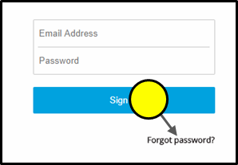Select **Forgot Password?**
2. 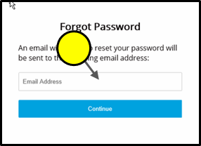Enter your email address and click **Continue.**
3. Close the browser window after receiving the below confirmation.

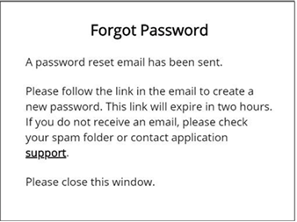

1. You will receive an email from [DeloitteSSPRInformation@deloitte.com](mailto:DeloitteSSPRInformation@deloitte.com), then click the enclosed link to reset password. If you do not receive this email and it is not in the junk/spam folder, please contact your Deloitte tool administrator. **Please note that the password reset link expires after 2 hours.**

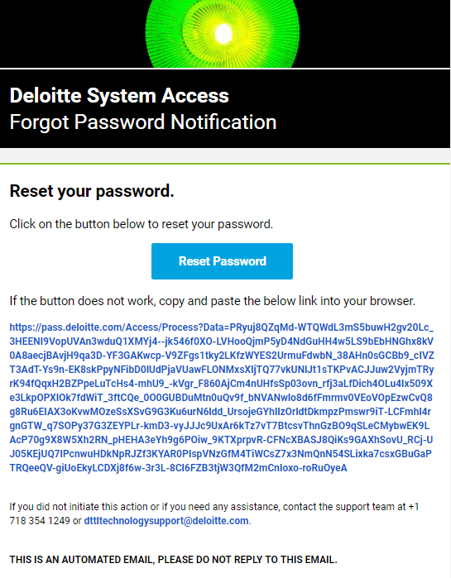

1. 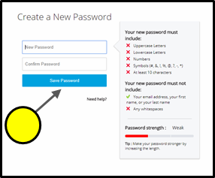Enter new password and click **Save Password.**

Deloitte refers to one or more of Deloitte Touche Tohmatsu Limited, a UK private company limited by guarantee (“DTTL”), its network of member firms, and their related entities. DTTL and each of its member firms are legally separate and independent entities. DTTL (also referred to as “Deloitte Global”) does not provide services to clients. Please see [www.deloitte.com/about](http://www2.deloitte.com/global/en/pages/about-deloitte/articles/about-deloitte.html) to learn more about our global network of member firms.

Deloitte provides audit, consulting, financial advisory, risk management, tax and related services to public and private clients spanning multiple industries. Deloitte serves four out of five Fortune Global 500® companies through a globally connected network of member firms in more than 150 countries bringing world-class capabilities, insights, and high-quality service to address clients’ most complex business challenges. To learn more about how Deloitte’s approximately 225,000 professionals make an impact that matters, please connect with us on Facebook, LinkedIn, or Twitter.

This communication contains general information only, and none of Deloitte Touche Tohmatsu Limited, its member firms, or their related entities (collectively, the “Deloitte network”) is, by means of this communication, rendering professional advice or services. Before making any decision or taking any action that may affect your finances or your business, you should consult a qualified professional adviser. No entity in the Deloitte network shall be responsible for any loss whatsoever sustained by any person who relies on this communication.